Employee Leave Management System

Contents
1. Overview
2. Resources
1.Admin
2.Employee
3.Manager
1.Overview
This documentation describes how to works the Employee Leave Management System.

2.Resources
Admin
ADMIN Signup
The Admin signup
http://localhost/Leave/public/admin
In the body we should pass the data
Username : Karthick
Password : karthi1016
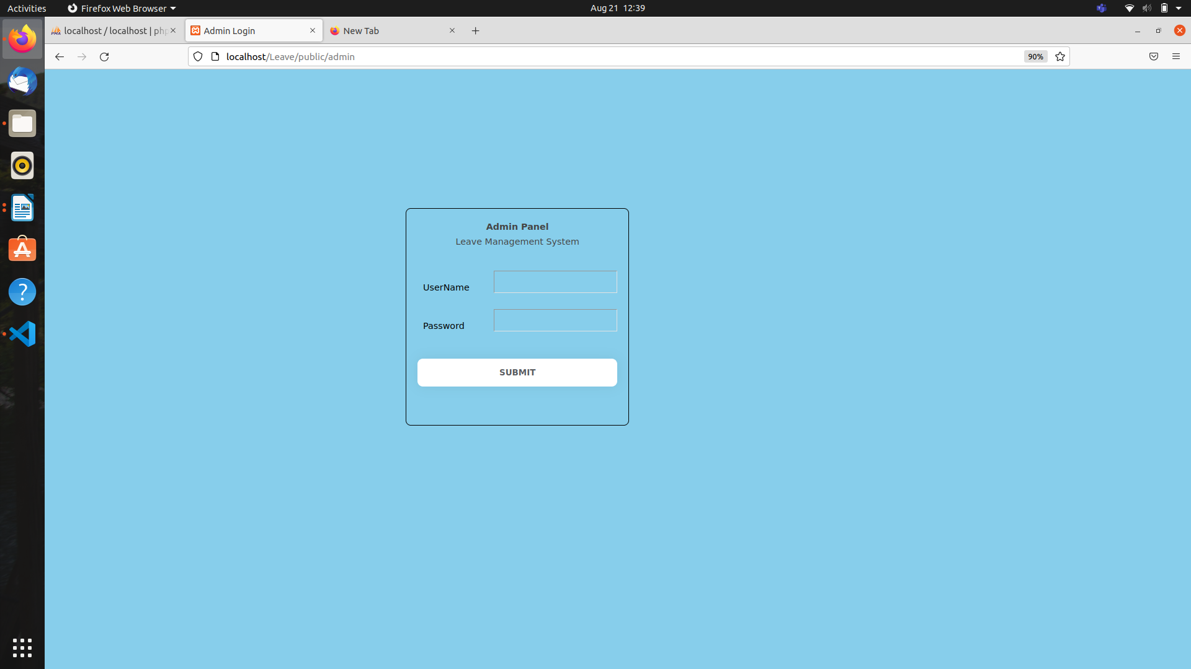

It redirects the Admindashboard Page when signin successfully or return the error message.

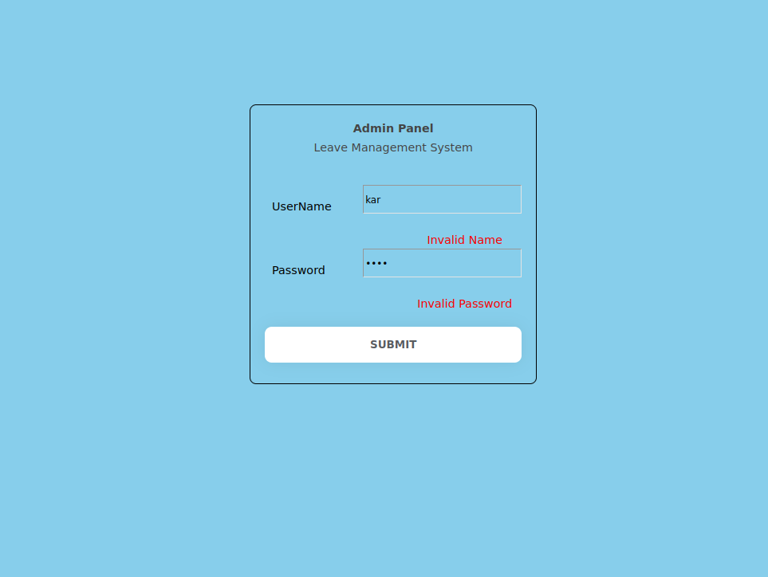
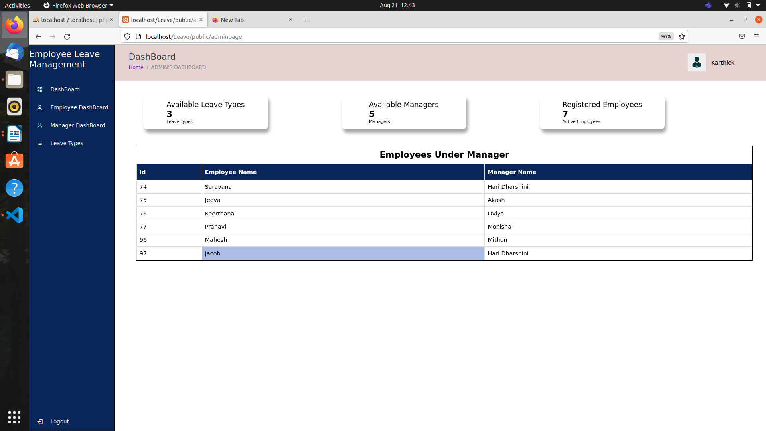

Where a Admin Object is

Field | Type | Description
id | integer | A unique identifier for the user.
username | varchar | The Admin username
password | varchar | The Admin password

In Admin Dashboard

Employee Page

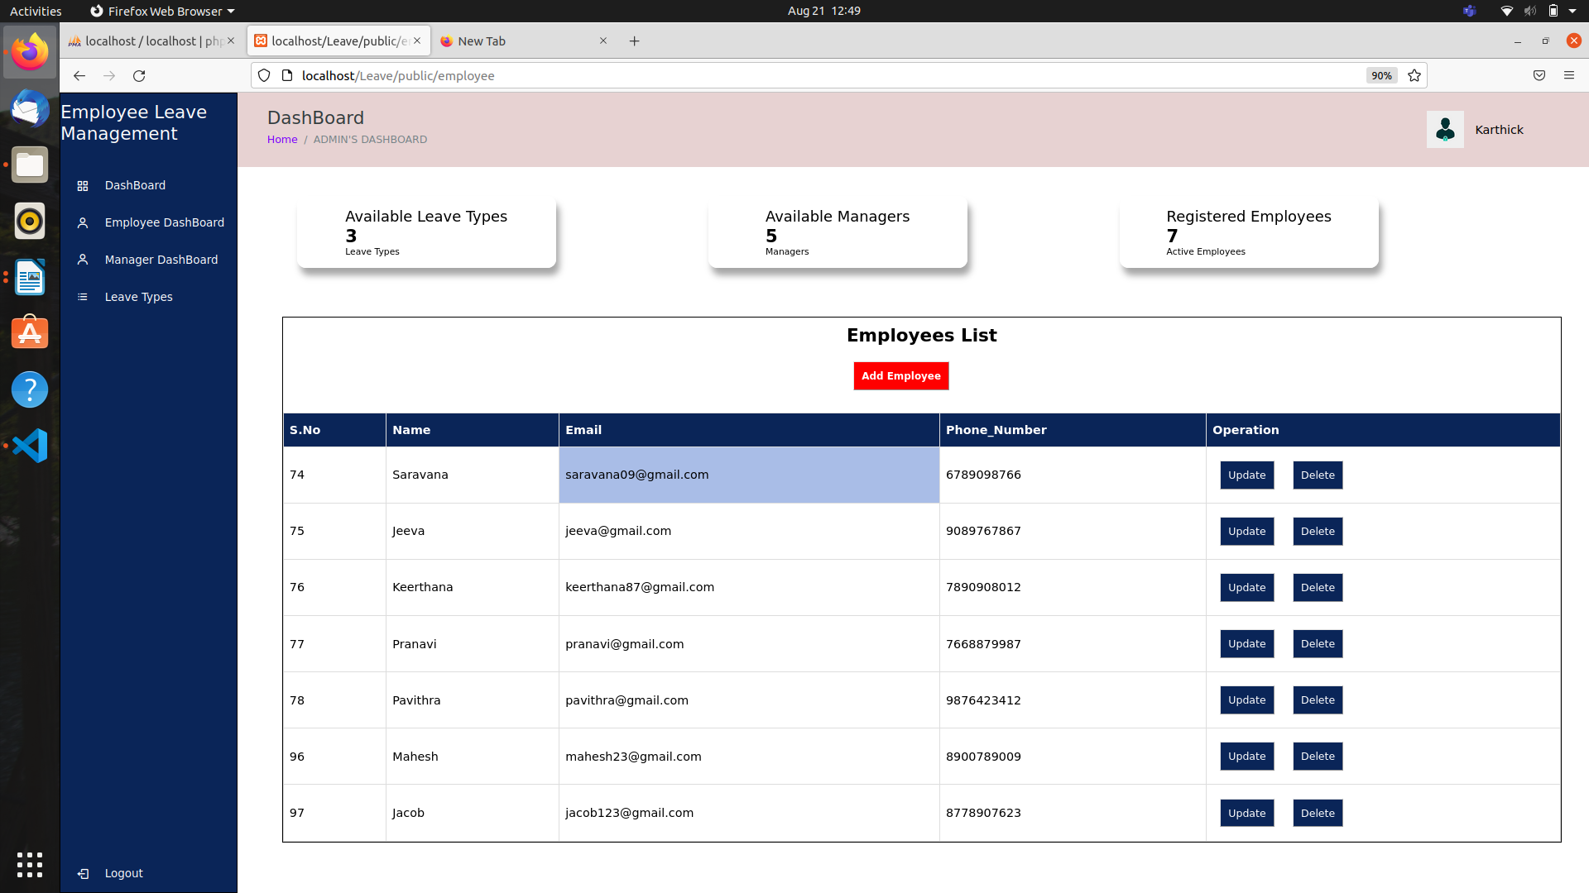
In this Page,Admin can be add or update or delete the Employees.
In Add Employee Admin can add the new Employees, if admin added new employee it returns a successful message or return error.

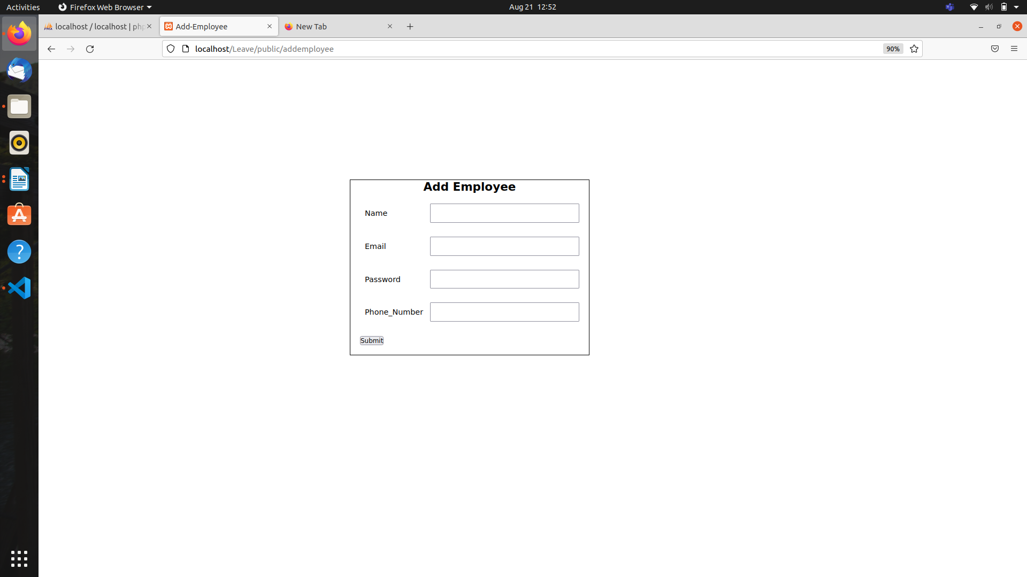
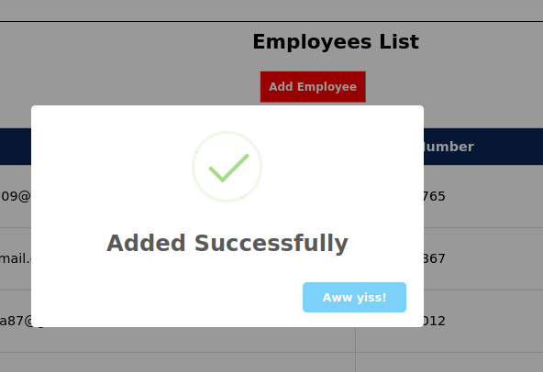

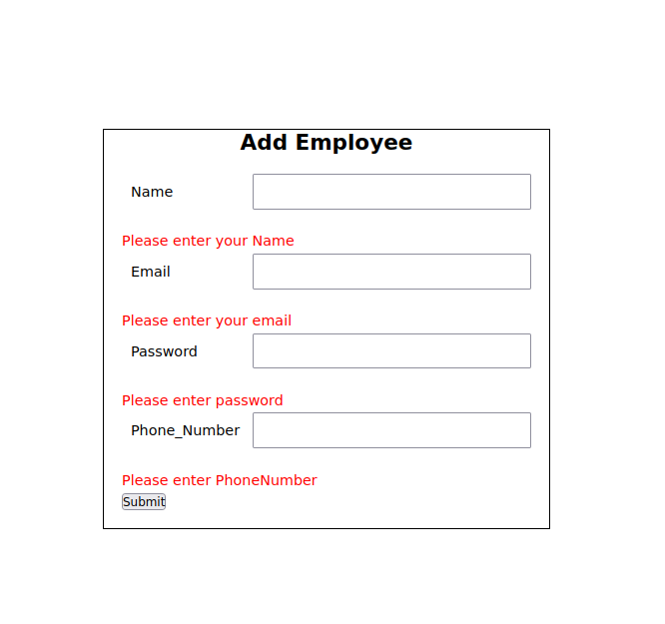

Field | Type | Description
id | int | A unique identifier for the user.
name | varchar | The employee name
email | varchar | The employee email
password | varchar | The employee password
phonenumber | int | The employee phonenumber

In Update page, Admin can update the name or email or password or phonenumber of the employee. If Admin update it gives a successfull message.
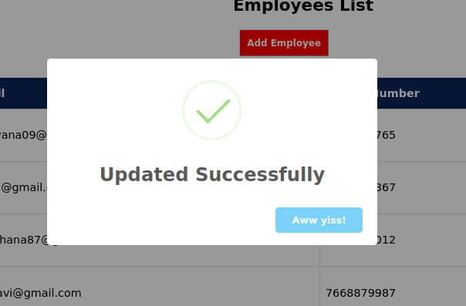
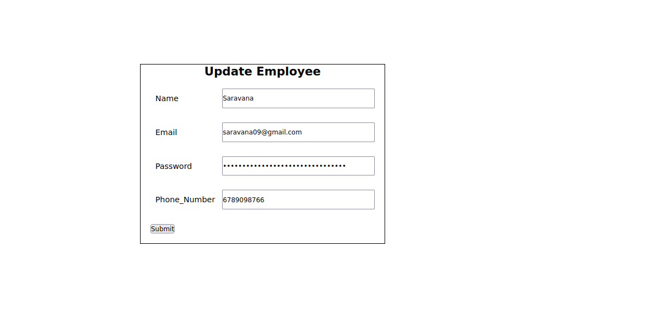

Manager Page
In this Page,Admin can be add or update or delete the Manager.
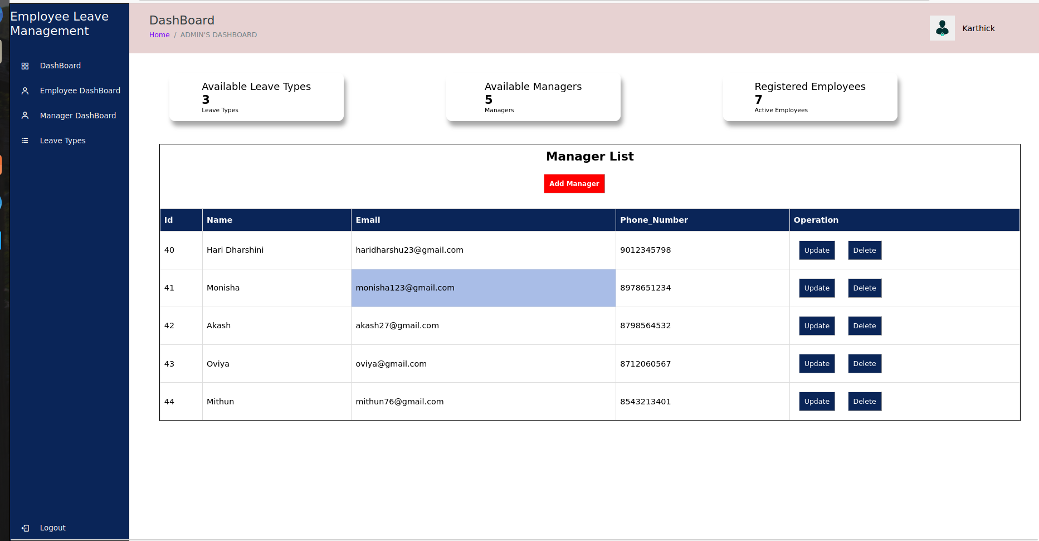

In Add Manager Admin can add the new managers, if admin added new manager it returns a successful message or return error.
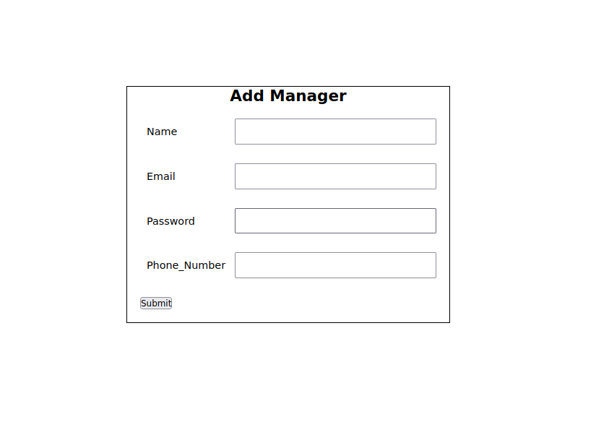
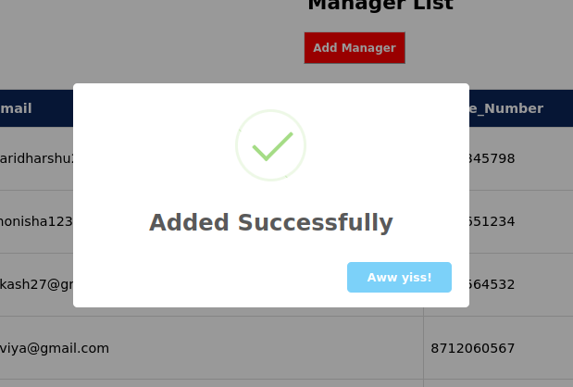

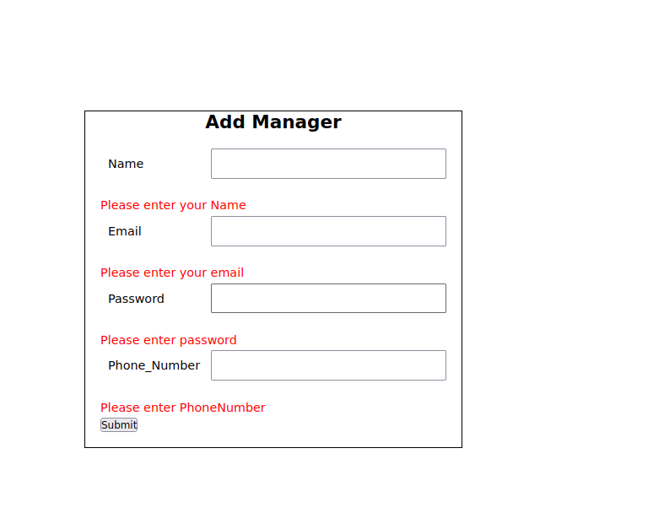

Field | Type | Description
id | int | A unique identifier for the user.
name | varchar | The manager name
email | varchar | The manager email
password | varchar | The manager password
phonenumber | int | The manager phonenumber

In Update page, Admin can update the name or email or password or phonenumber of the manager and assign employee for a manager. If Admin update it gives a successfull message.

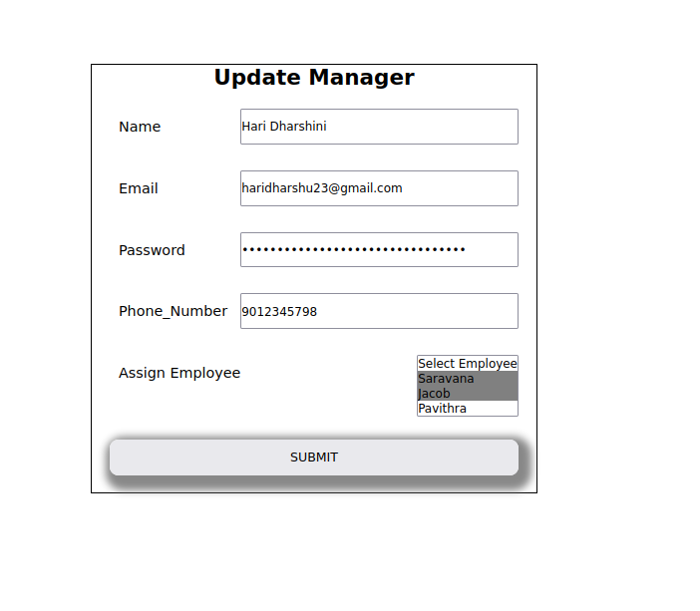
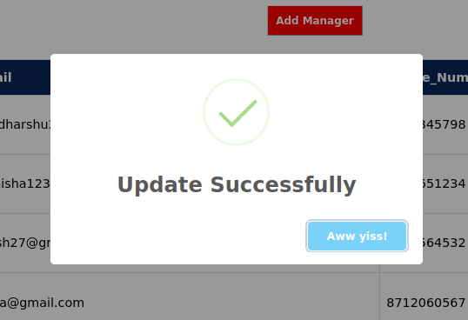

Leave Page
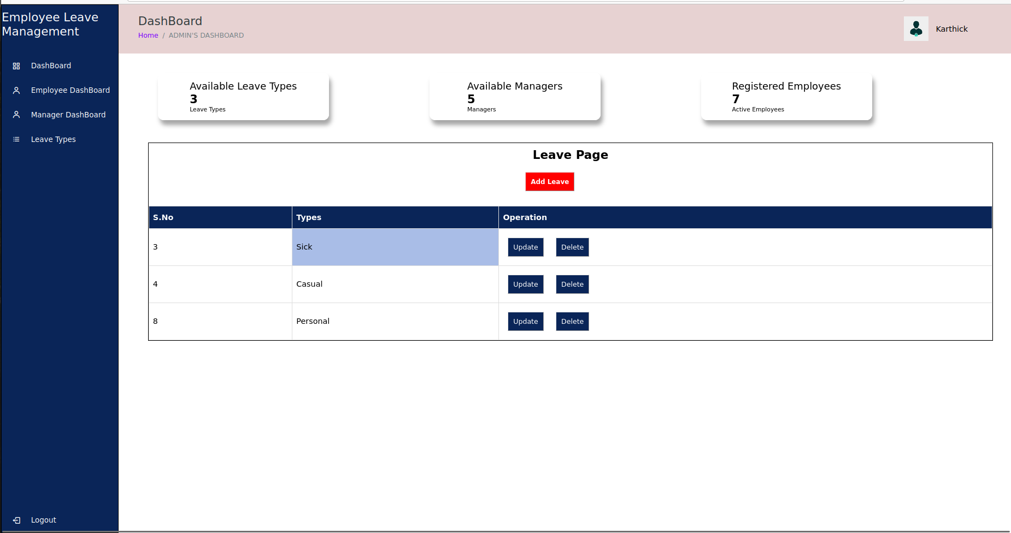
In this Page,Admin can be add or update or delete the Leave Types.
Employee
EMPLOYEE Signup
The Employee signup
http://localhost/Leave/public/login
In the body we should pass the data
Email : saravana09@gmail.com
Password : saravana78
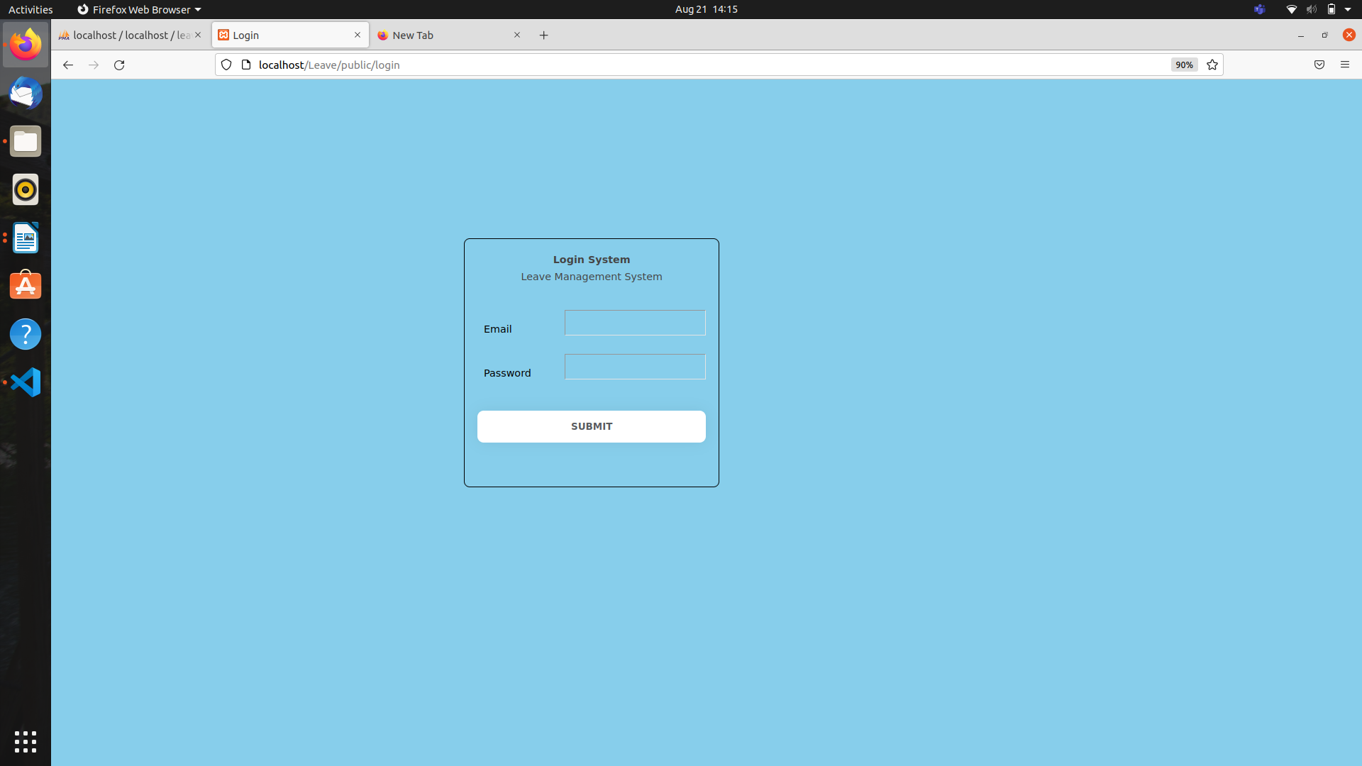

It redirects the Employee dashboard Page when signin successfully or return the error message.
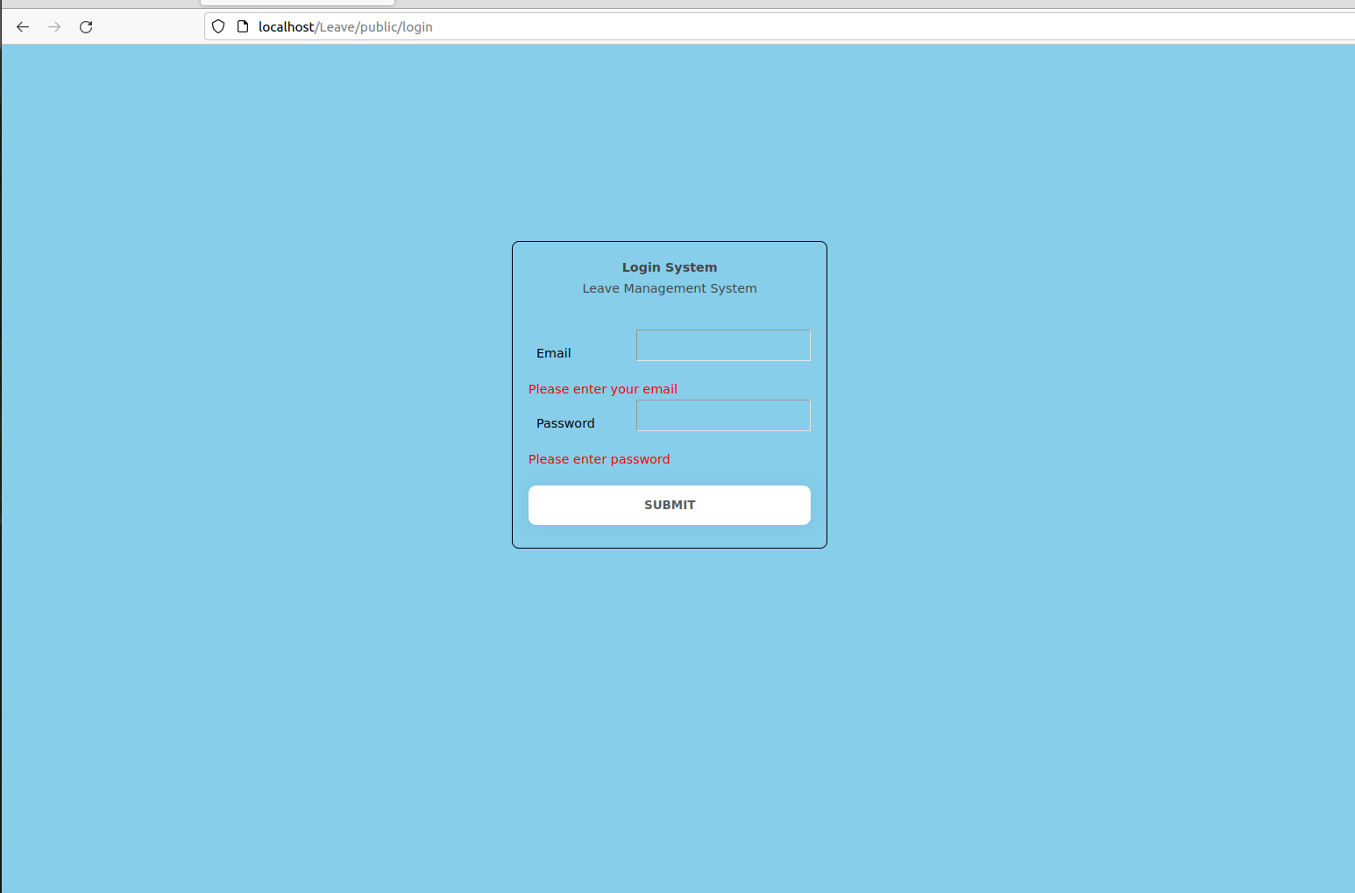
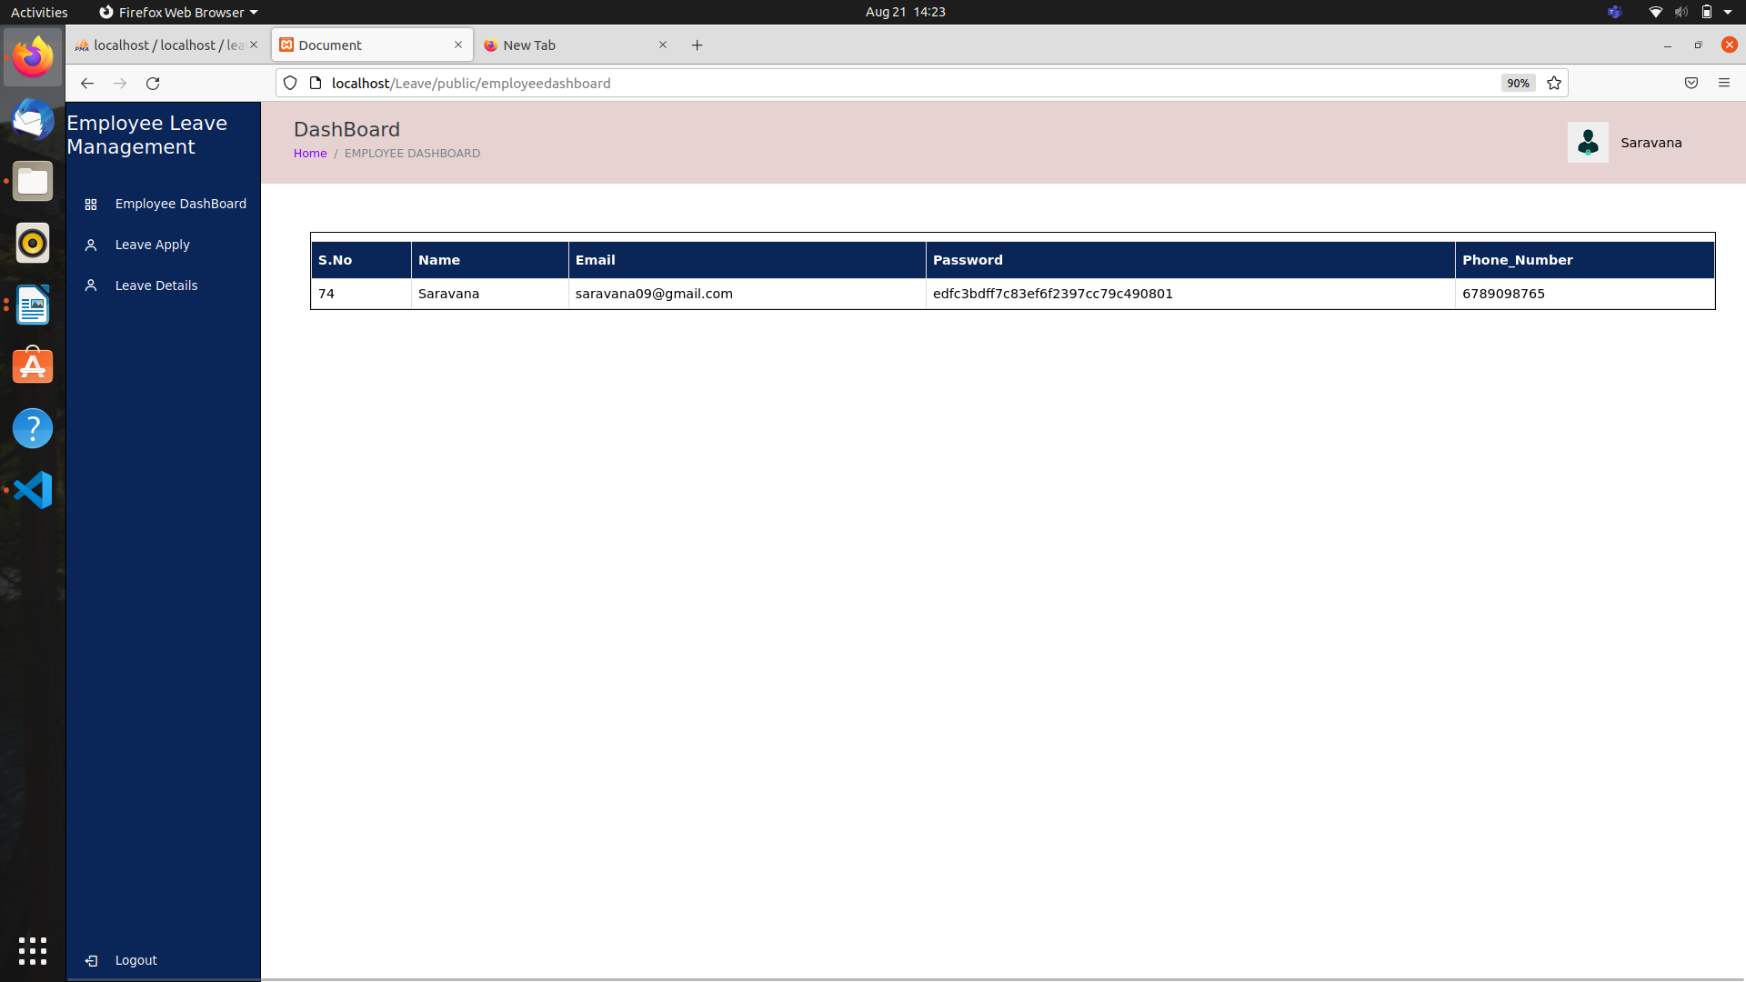

In Employee dashboard page it shows the employee details

Where a Employee Object is

Field | Type | Description
id | integer | A unique identifier for the user.
email | email | The Employee email
password | varchar | The Employee password

Leave Apply page
In this page Employee can apply a leave , it automatically sends to his manager.

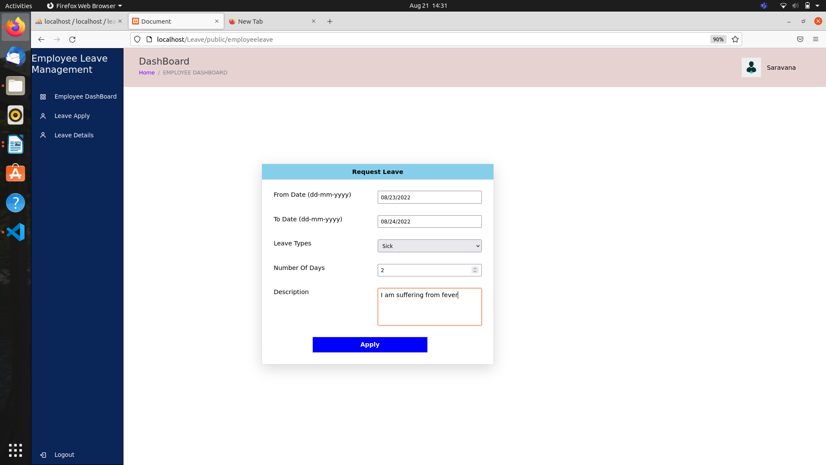

Leave Details
In this page,After apply a leave if it applies it gives a successful message and the details of the leave and status of the leave whether his manager approve or declined or pending.

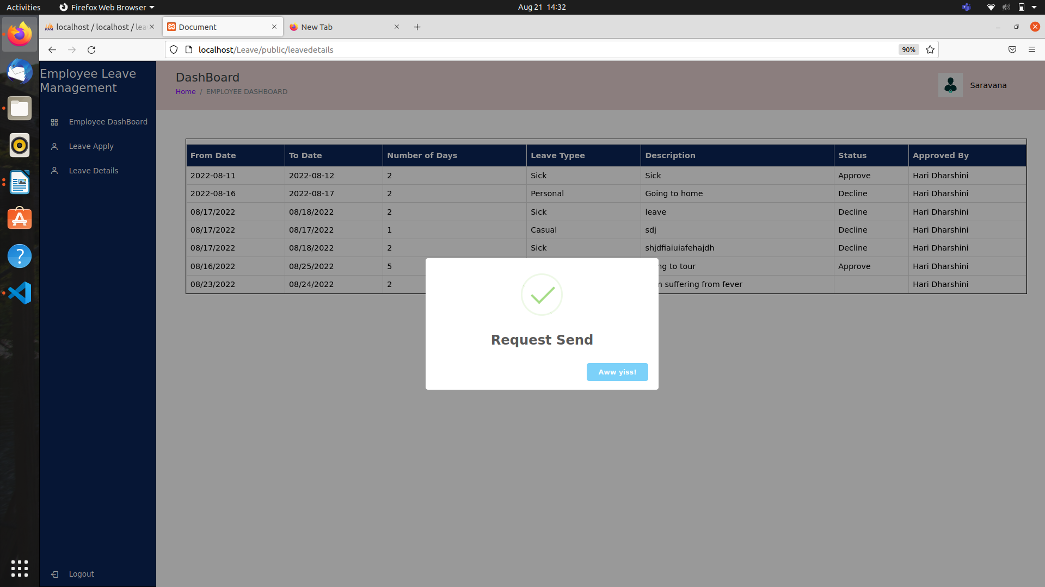

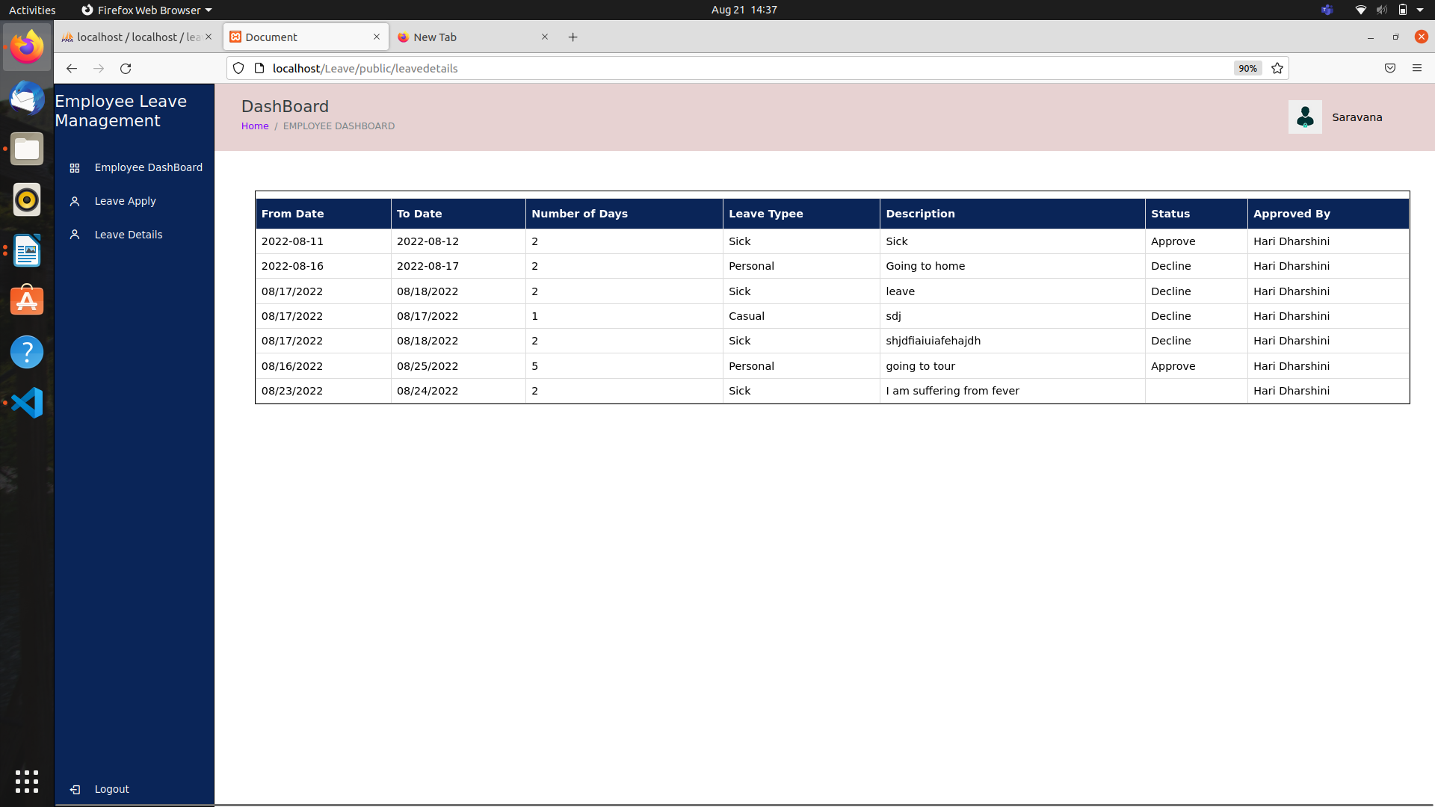
MANAGER
MANAGER Signin
The Manager signin
http://localhost/Leave/public/login
In the body we should pass the data
Email : haridharshu23@gmail.com
Password : haridharshu123

It redirects the Employee dashboard Page when signin successfully or return the error message.

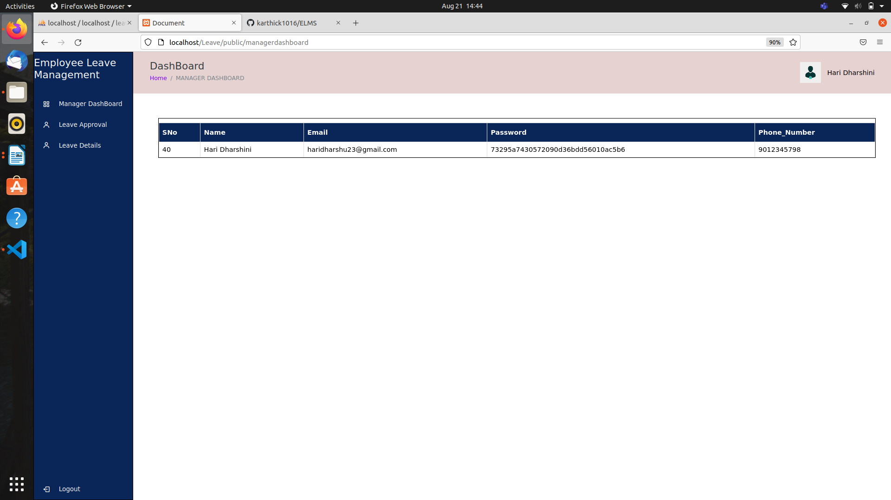
In Manager dashboard page it shows the manager details

Leave Approval
In leave approval page Manager can approve or decline the employee leave request
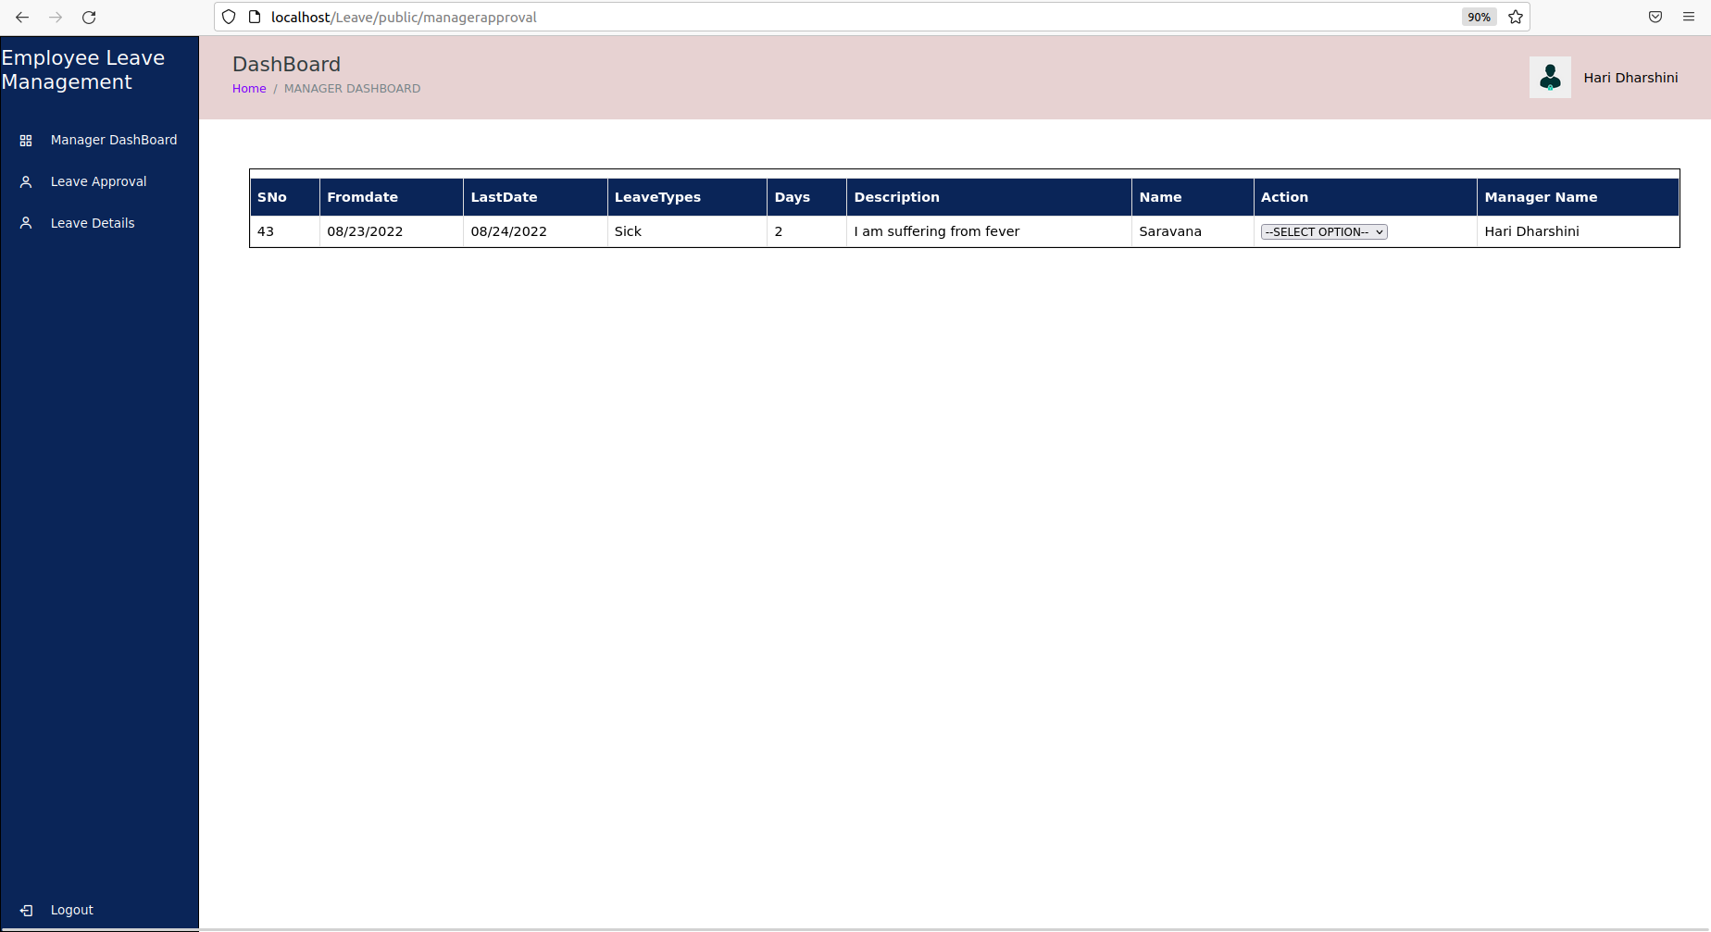

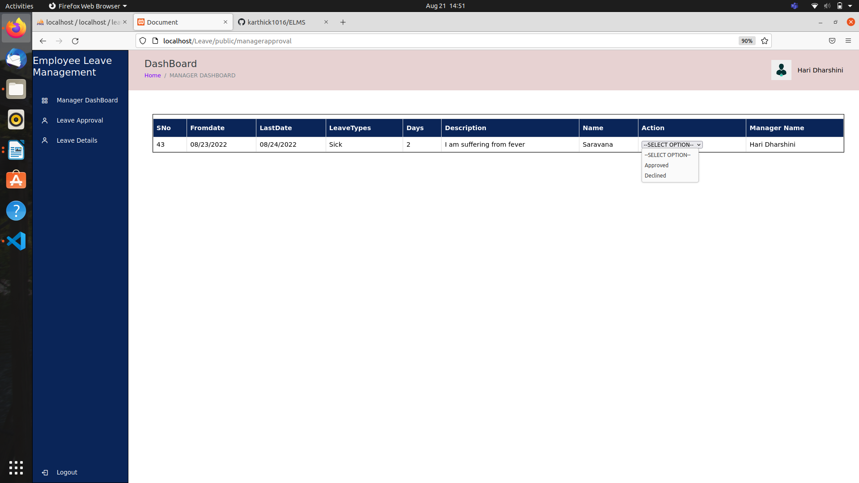

Leave Details
In Leave details page the leave details of the employee under the manager with the status of the leave.


